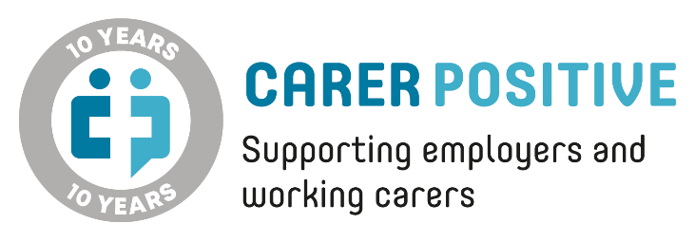
10th Anniversary Awards 2024

To be considered for this award, please complete the form below and return it to info@carerpositive.org.
Best Employer for Communication and Awareness Raising
Overview of what we are looking for:
A workplace and culture where support for carers is visible, understood, and well communicated at all levels. This can be through internal communication channels/ staff intranet/ portals/ team meetings/ etc. and with awareness raising undertaken to ensure staff are carer aware.

Points of good practice:
- Senior level endorsement/championing of carer support
- Line manager training to ensure understanding and consistency
- Raising awareness across as many different routes as possible and throughout the year
- Linking to external events and awareness campaigns such as Carers Week to reach staff

- Please provide a description of how your organisation raises awareness and communicates support for carers across all staff.
- How long has this been in place?
Have carers been involved in awareness raising/communications?
If so, please explain how.
- Has any review of the success of this been undertaken?
(evidence, feedback from carers etc or any data gathered from awareness raising activities)
- Please provide at least one testimonial from a carer who has been involved in awareness raising/communication activities or a carer who has sought support as a result of these.

